2509 CS460

Computer Vision

HW3: Practices on Deep Learning and Convolutional Neural Networks

Chinese Name:陈展
Student ID:1230015070

Task1：
L=x*y+x*z+y*z
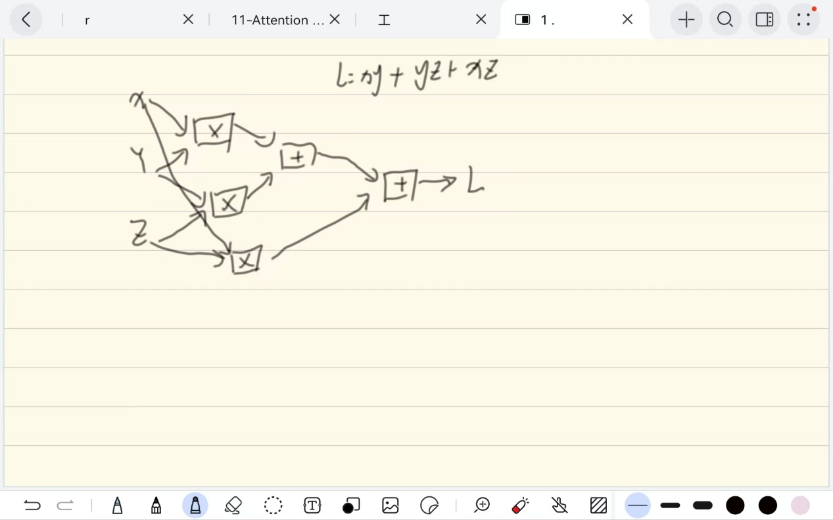
Task4:
Best Model:
learning_rate = 0.01
reg = 0.001
num_train = 45000
hidden_dim = 256
batch_size = 200
num_epochs = 20
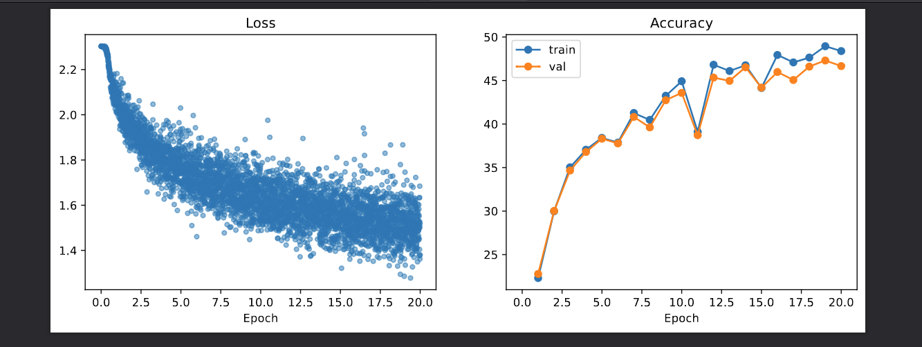
Test-set accuracy: 46.64
Overfit Model:
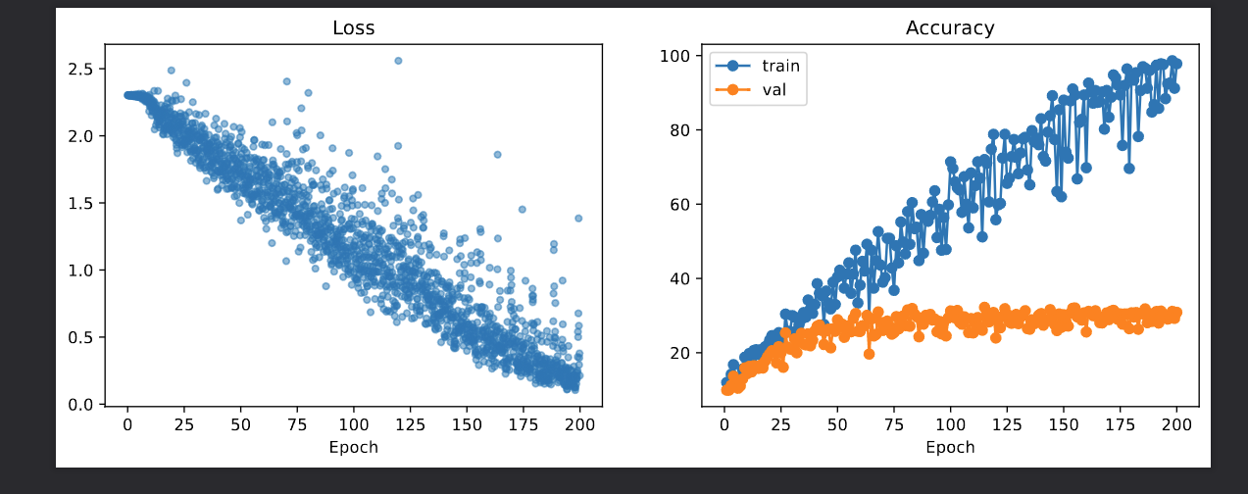
learning_rate = 0.05
reg = 0
num_train = 500
hidden_dim = 128
batch_size = 50
num_epochs = 200
The model achieved 97.8% training accuracy, while the validation accuracy remained low (~30%), successfully demonstrating overfitting.
Task5:
Model Architecture:
I implemented a Convolutional Neural Network (CNN) with the following structure:
- Conv2d (1 input -> 32 filters, 3x3 kernel, padding=1) + ReLU + MaxPool2d (2x2)
- Conv2d (32 inputs -> 64 filters, 3x3 kernel, padding=1) + ReLU + MaxPool2d (2x2)
- Flatten
- Linear (Fully Connected) (6477 -> 512 units) + ReLU + Dropout (p=0.5)
- Linear (Output) (512 -> 10 classes)
• Hyperparameters:
- Optimizer: Adam
- Learning Rate: 0.001 (1e-3)
- Batch Size: 64
- Num Epochs: 15
• Training & Validation Plot:
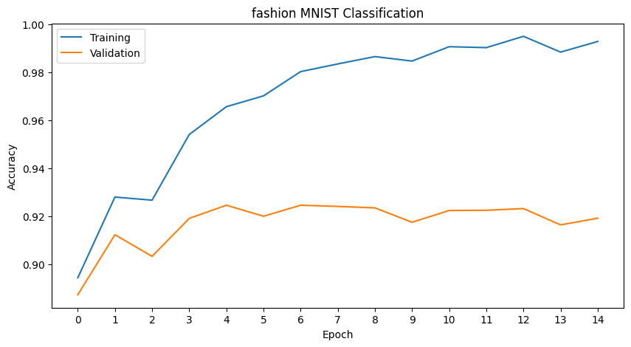
Final Test Accuracy:
91.29%
Task6:

Reasonable Prediction:
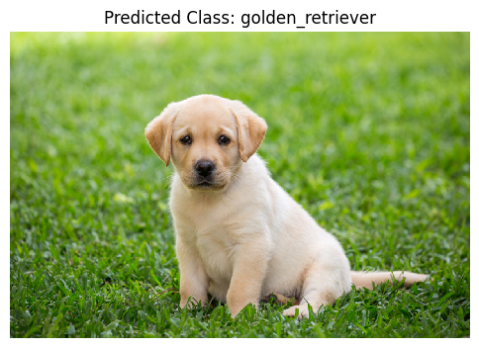
Description:
"I used an image of a golden retriever puppy. The pre-trained SqueezeNet model correctly predicted it as 'golden_retriever'. This is a reasonable prediction because the object in the image is clear, distinct, and belongs to one of the 1000 categories in the ImageNet dataset."

Unreasonable Prediction:
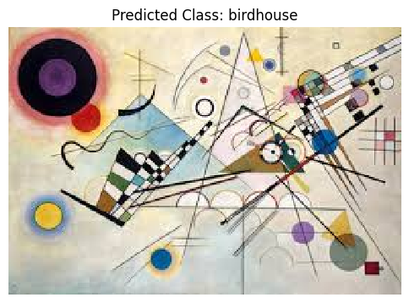
Description:
"I used an image of an abstract geometric painting (by Kandinsky). The model incorrectly predicted it as 'birdhouse'. This is an unreasonable prediction because the image does not contain any physical birdhouse. The model likely confused the sharp triangular shapes and lines in the painting with the structural features of a birdhouse, demonstrating its inability to generalize to abstract art outside its training domain."

